**Overview**

In this second CS2002 Practical, I was asked to comment some Assembler code, as well as design and implement a StackFrame module that provides the functionality to establish the base pointer and return address in the caller’s stack frame and print out stack frame data. I also had to implement test files to make sure that my implementation worked.

I’m proud to say that I’ve achieved the previously established goals:

* I’ve commented the Factorial-Commented.s file.
* I’ve implemented the StackFrame module.
* I’ve added tests.

**Assembler commenting**

As required in the Stage 1 of this practical’s [System Specification](https://studres.cs.st-andrews.ac.uk/CS2002/Coursework/W08-C-Architecture/W08-C-Architecture.pdf), I examined the assembly code in Factorial-Commented.s, and wrote comments for the *factorial* function. The comments are written after each line of assembly code that is not an assembler directive (that starts with a .), as show in *Figure 1*:

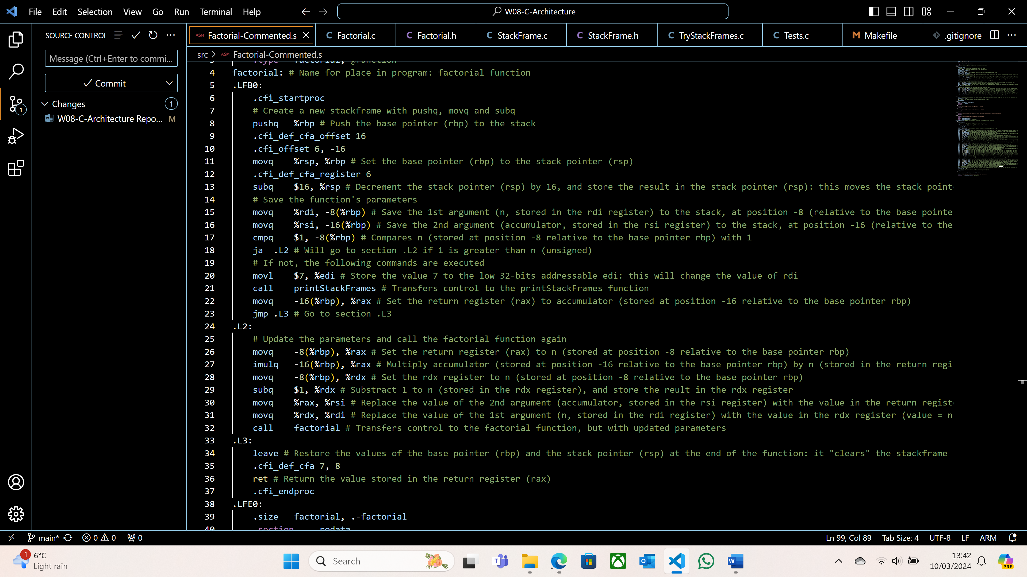

*Figure 1: Some comments in Factorial-Commented.s*

Note that I also decided to write comments for the *executeFactorial* function. This is not required by the [System Specification](https://studres.cs.st-andrews.ac.uk/CS2002/Coursework/W08-C-Architecture/W08-C-Architecture.pdf), but I still decided to do so as it gave me a better understanding of Assembly and x86-64, as well as what *executeFactorial* does.

**Design and Implementation**

I only had to implement 4 functions in StackFrame.c:

* *getBasePointer*
* *getReturnAddress*
* *printStackFrameData*
* *printStackFrames*

The design of the functions as well as what they do was already implemented and explained in the header file, StackFrame.h. All I had to do was complete those functions.

*getBasePointer* uses inline assembly to get the base pointer in the stack frame of the function that called *getBasePointer*. The base pointer is stored in x86-64 in the *rbp* register. However, if the function simply accessed the value stored in *rbp*, it would return the base pointer of *getBasePointer*, not the function of *getBasePointer*. This is why I get the value stored in the register at position 0 relative to *rbp*, using inline assembly.

To get the return address, I first had to get the base pointer in the stack frame of the function that called *getReturnAddress*, using the same inline assembly command as in *getBasePointer* and storing it in the variable *base*. The return address being stored in the register with position 8 relative to the base pointer, I used the *movq* assembly operation to copy the value stored in the register with position 8 relative to *base* to a new variable *address*, which I then returned.

The next function that I had to implement was *printStackFrameData*. I started by examining the [System Specification](https://studres.cs.st-andrews.ac.uk/CS2002/Coursework/W08-C-Architecture/W08-C-Architecture.pdf), and I managed to identify a few patterns:

1. Firstly, there are $n+2$ stack frames printed out, $n$ being the number used in the *factorial* function. So, for a default value of $n=6$, 8 stack frames are printed out.
2. Secondly, each stack frame follows the same format: one line of data is printed out, followed by a line of “-“ signs (13 of them), and then the rest of the data is printed out.
3. Thirdly, the number of lines is equal to the difference between the previous base pointer and the current base pointer, divided by 8 (as we want 8 bytes per line).
4. Fourthly, the first hexadecimal number in the first line of a stack frame is the same as the second hexadecimal number in the first line of the previous stack frame. Therefore, I deduced that in the first line of each stack frame, the first hexadecimal number is the current base pointer, and the second number is the value stored at this address, which here is the previous base pointer.
5. Finally, the 8 individual hexadecimal numbers that are printed after the “--” are identical to the second hexadecimal number in reverse order (and taking each digit in pairs).

The first thing to do in *printStackFrameData* was to compute the size of the stack frame: this is the previous base pointer minus the current base pointer. I then used a *for* loop to repeat the next steps a certain number of times, according to pattern 3. I then created a string of size 16 (17 in c, as it counts the null character) to store the first hexadecimal number: the base pointer. I used the *sprintf* method to format the string accordingly (in hexadecimal, with leading 0 if necessary). I used inline assembly to get the second hexadecimal number (the value stored at the address of the first number), formatted it in the same format as the first hexadecimal number, and then printed both numbers. The next step was to output the 8 individual hexadecimal numbers. To do so, I cycled through the return address in reverse order, two-by-two, and printed out those numbers after a “--“. Finally, I had to update the previous base pointer to the value stored in the current base pointer and increase the current base pointer by 8.

*printStackFrames* prints out an inputted number of stack frames starting from the caller's stack frame. I started by initialising the base pointer using *getBasePointer*. I then looped a certain number of times, according to the previously explained pattern 1. In this *for* loop, I set the previous base pointer to the previous value of the base pointer, I called the *printStackFrameData* function, and updated the base pointer to the previous base pointer (as explained in pattern 4).

**Testing**

The testing of my implementation can be divided into different sections:

* Running my code with a default value of $n=6$, using the Makefile and executing the TryStackFrames executable.
* Running my code with different values of $n$, which I did in the *Tests.c* file.
* Using disassembly with the *objdump -d TryStackFrames | less* command.

I will now explain the different steps of my testing, and why the outputs are valid.

As explained in the README.md file, I compiled and ran my code with a default value of $n=6$ using the Makefile, and this is the obtained output:

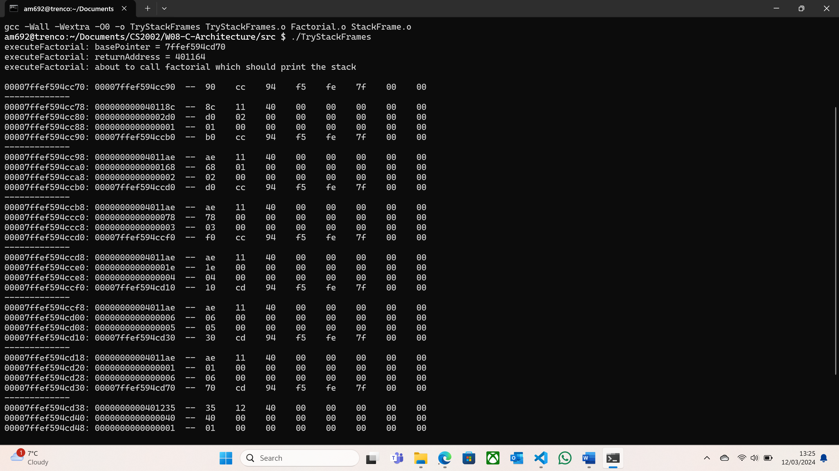

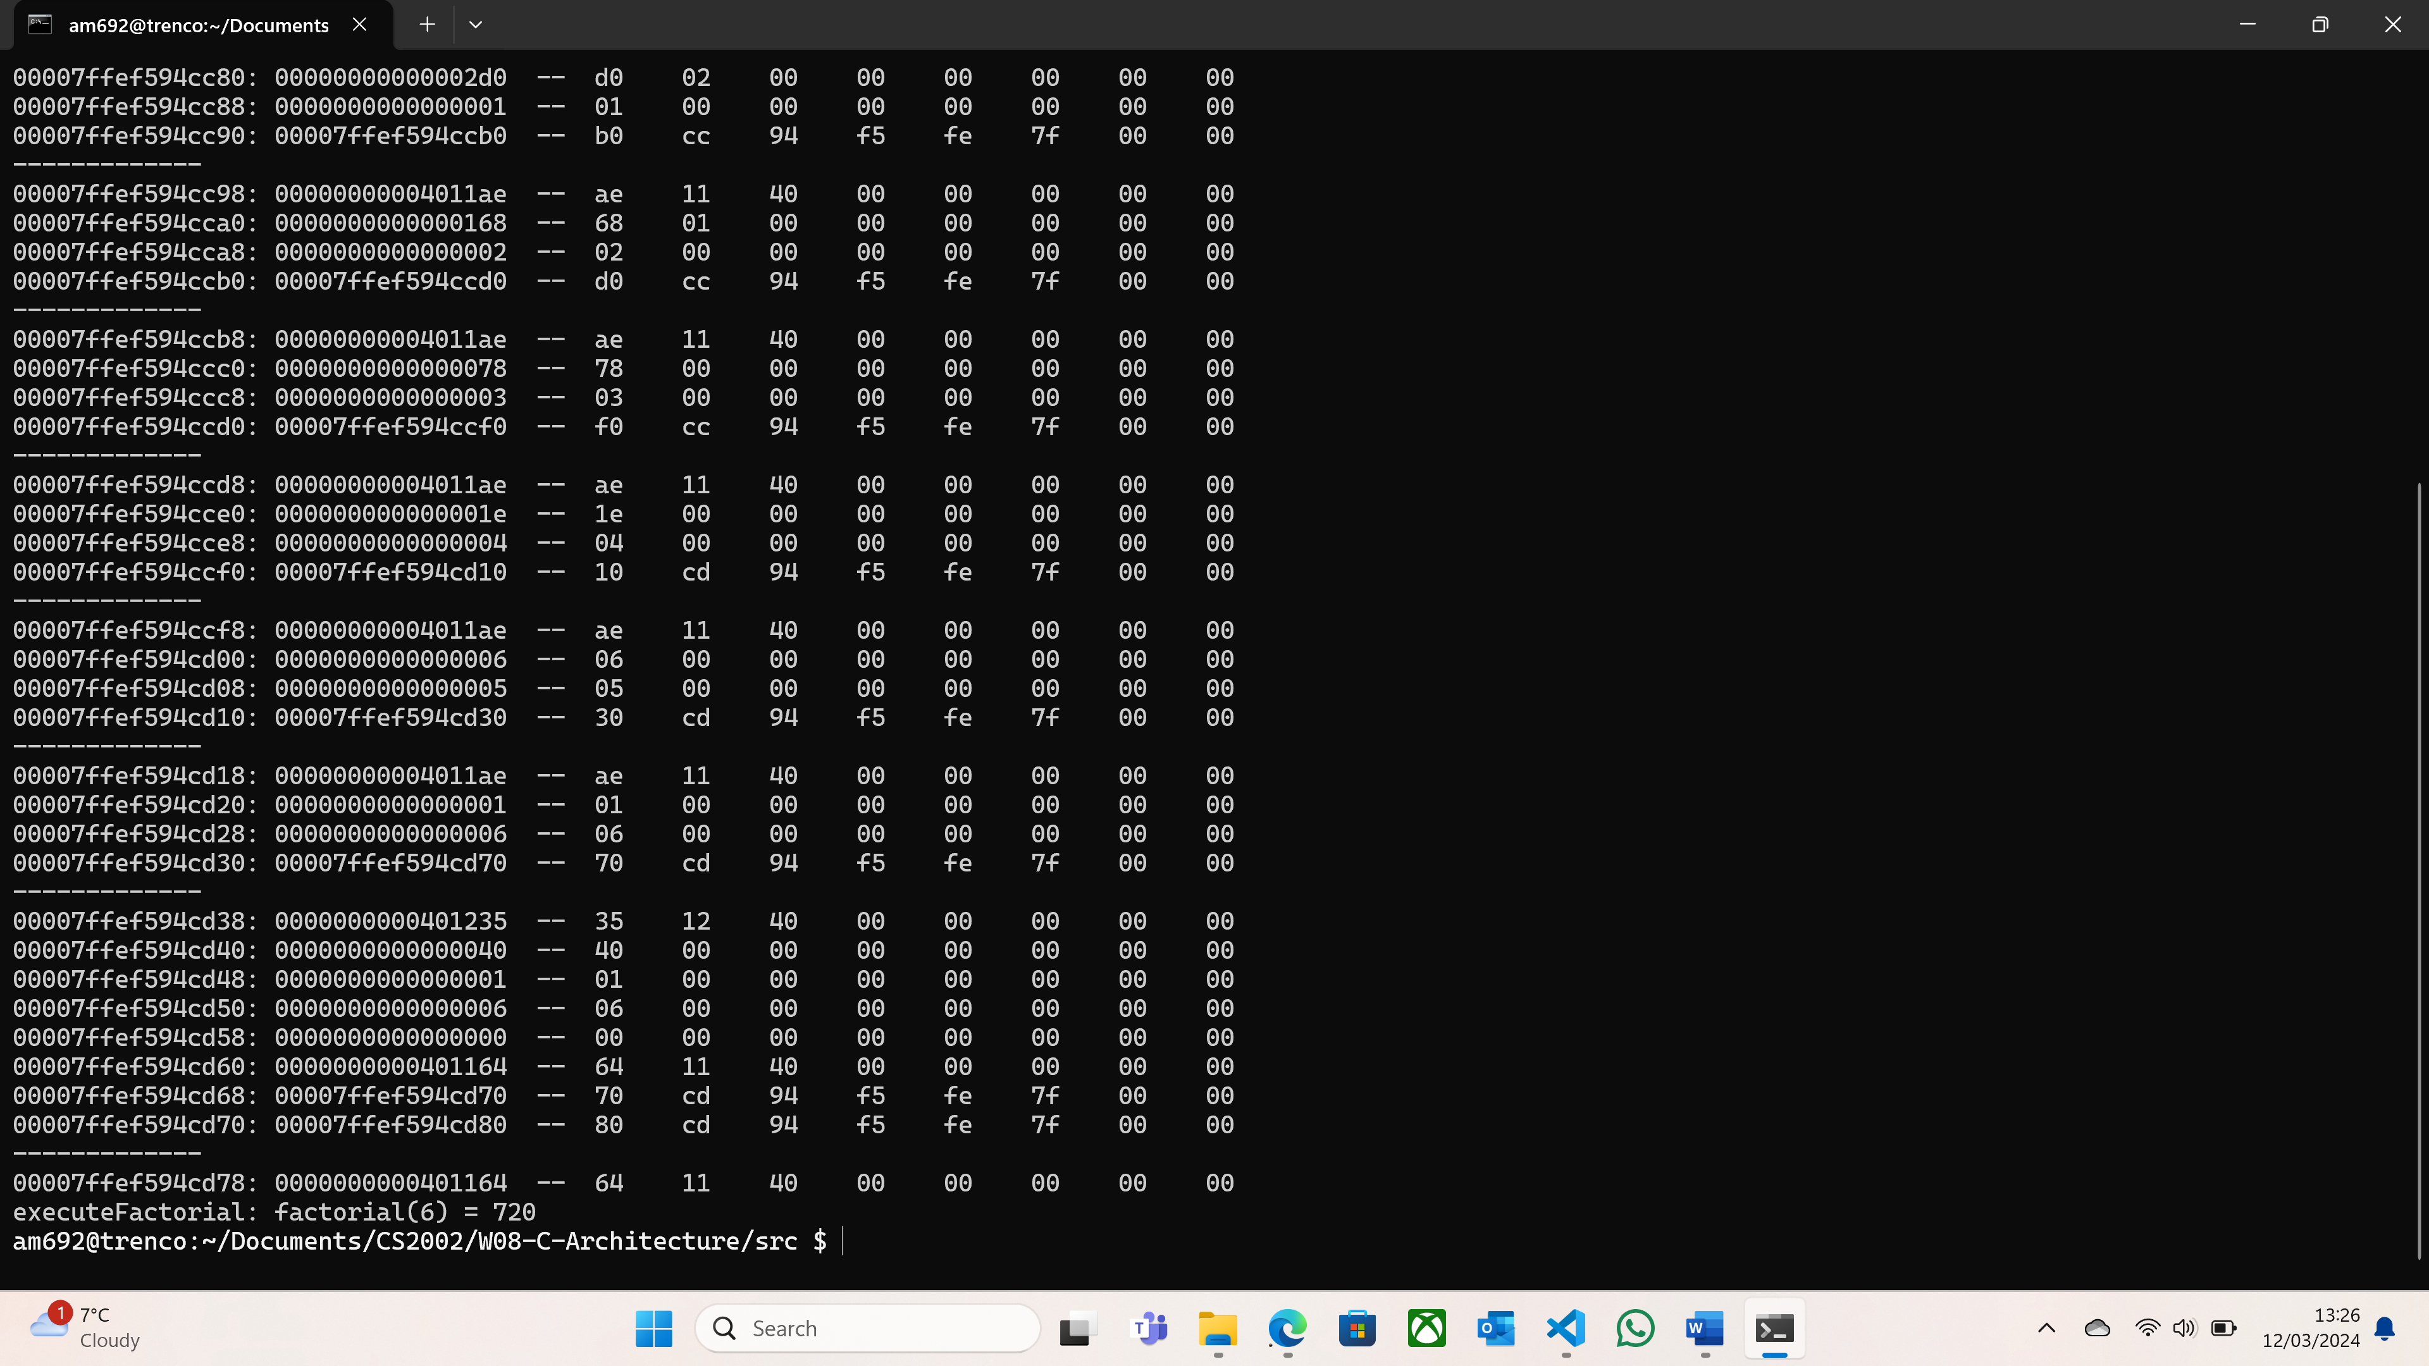

*Figure 2: ./TryStackFrames output*

We can immediately see that the format of the output is identical to the one in the [System Specification](https://studres.cs.st-andrews.ac.uk/CS2002/Coursework/W08-C-Architecture/W08-C-Architecture.pdf). Furthermore, all 5 previously stated patterns hold. We can also label some registers and what they contain: in each stack frame, the registers printed on the third and fourth lines are used to store the result of the recursive factorial number ($n×accumulator$, initialised at 1) and $n$ respectively, as well as what the different stack frames represent. Please see *Figure 3* for a visual analysis of this output.

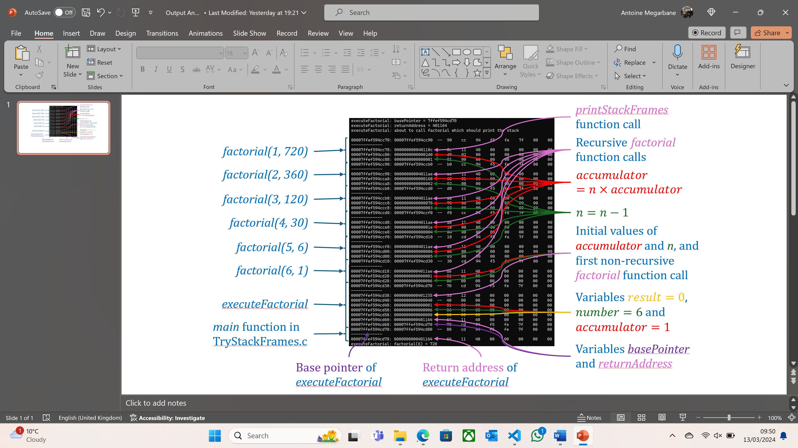

*Figure 3: Visual analysis of the ./TryStackFrames output*

Note that in each line, the first hexadecimal number corresponds to a register, and the second hexadecimal number is the value that is stored in this register. Also, the addresses in pink used for the different function calls are the return addresses of those functions.

I also implemented some extra testing in a separate test file called Tests.c: it contains 3 nearly identical copies of the *factorial* and *executeFactorial* functions, except that they don’t use *DEFAULT_VALUE_OF_N* but other macro variables defined in the header file Tests.h. This is done to test the stack frames for different values of *n*, not just the default value of $n=6$. I decided to implement three extra tests: one for a larger value of *n* (here $n=10$), one for a smaller value of *n* (here $n=3$), and one for $n=0$. After running it with the Makefile, we obtain the following output:

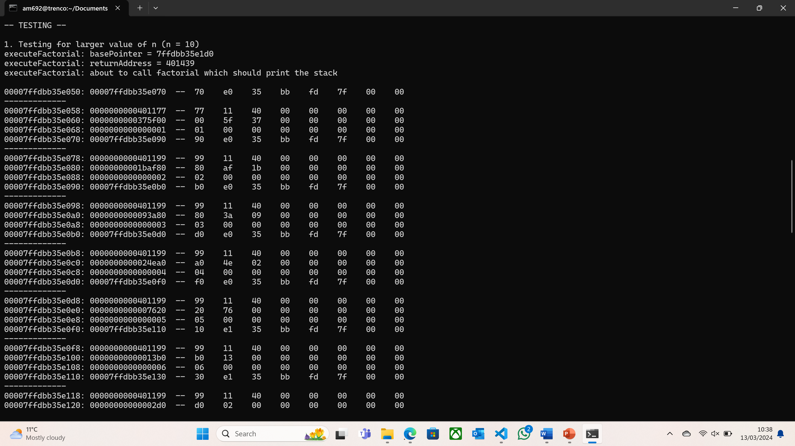

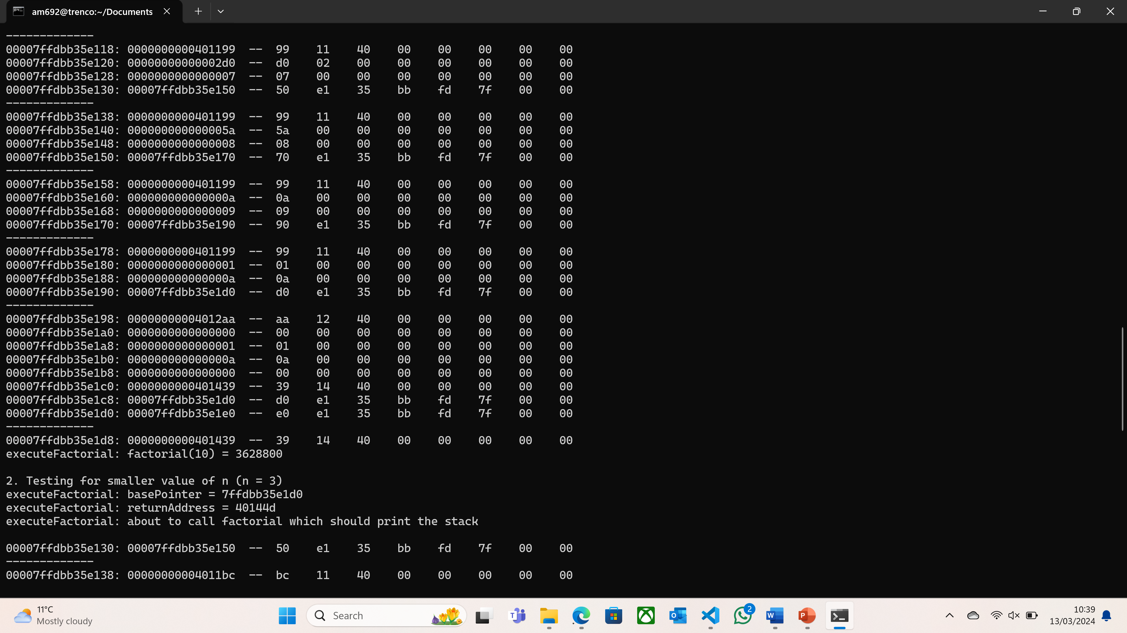

*Figure 4: Extract of ./Tests output (first test for $n=10$)*

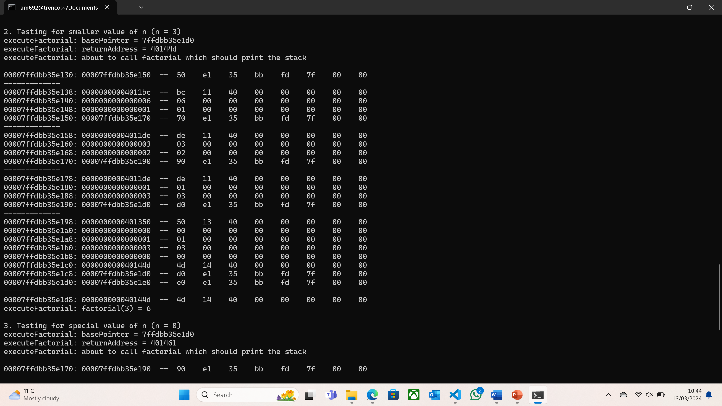

*Figure 5: Extract of ./Tests output (second test for $n=3$)*

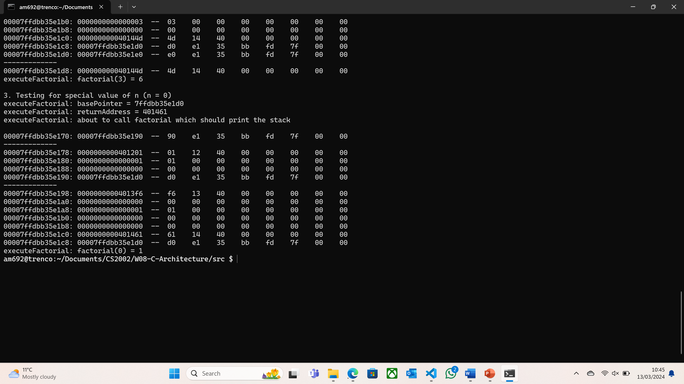

*Figure 6: Extract of ./Tests output (third test for $n=0$)*

The previously shown outputs follow the same format as the expected one in *Figure 2*. They also follow the same 5 patterns, and a visual analysis similar to the one done in *Figure 3* can be performed to analyse the results obtained here. One thing to notice is that there is no “last line” printed out in *Figure 6*: according to pattern 1, the number of stack frames printed out is equal to $n+2$. Therefore, as we are testing here for $n=0$, only two stack frames are printed out. And as the stack frames are outputted in “reverse order” (the *printStackFrames* call comes first, then the recursive *factorial* calls from 1 to *n*, then *executeFactorial*), the *printStackFrames* and *factorial(0, 1)* function calls (and their corresponding stack frames) will be printed out here.

Finally, I used the *objdump-d TryStackFrames | less* command to verify that my program is printing out the correct values, and this is an extract of the obtained output:

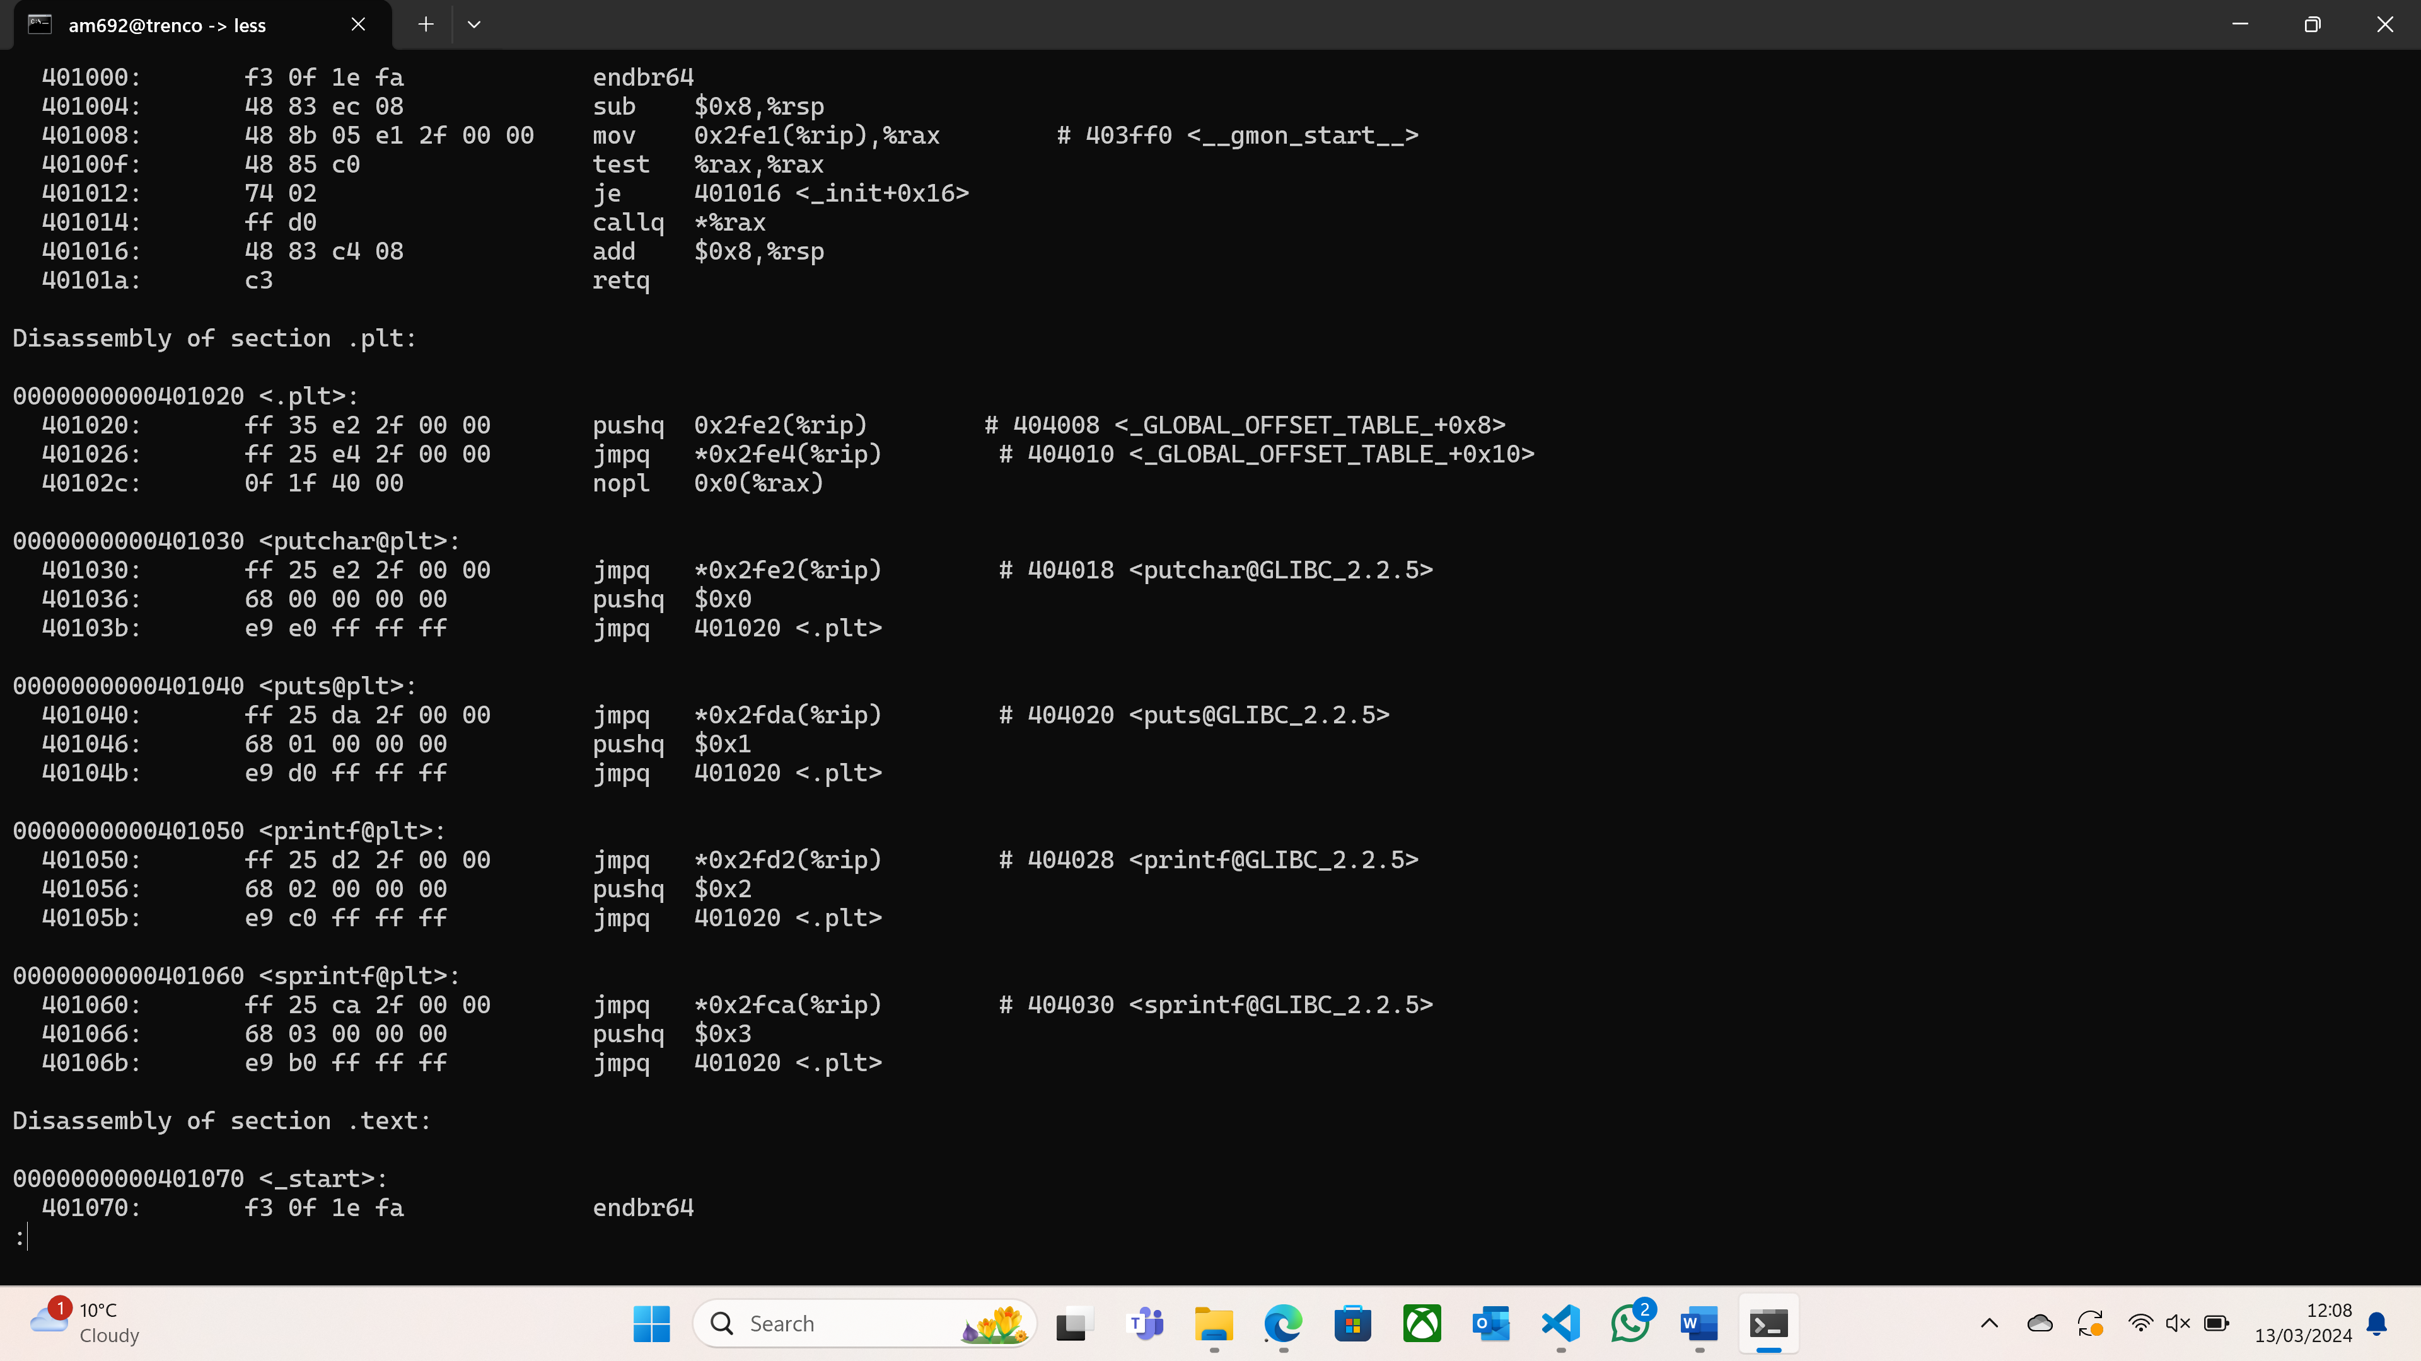

*Figure 7: Disassembly output for puts and printf*

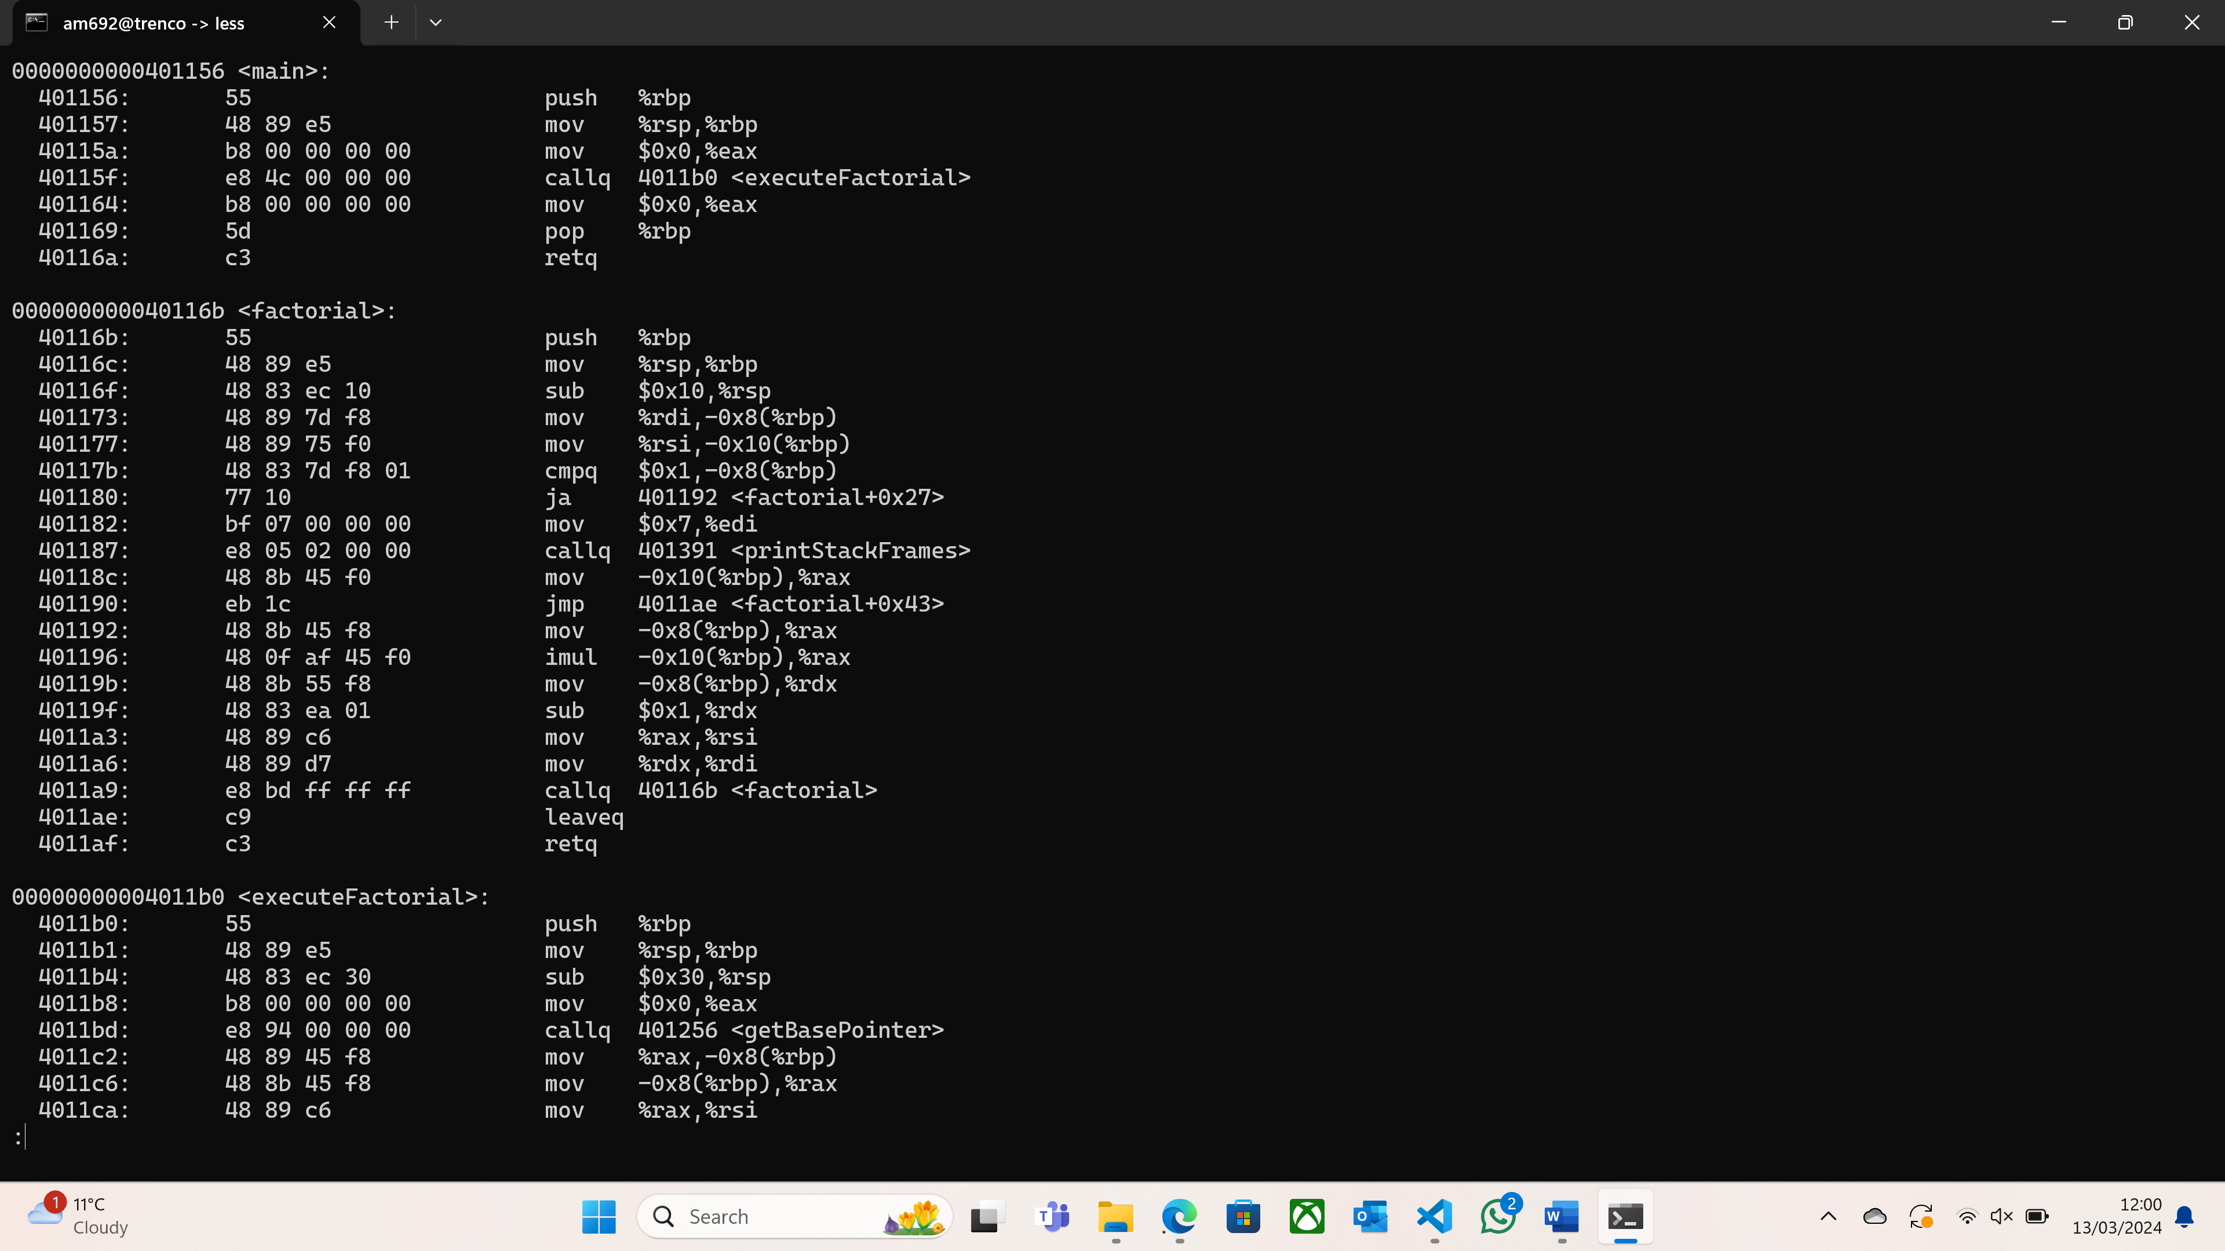

*Figure 8: Disassembly output for factorial*

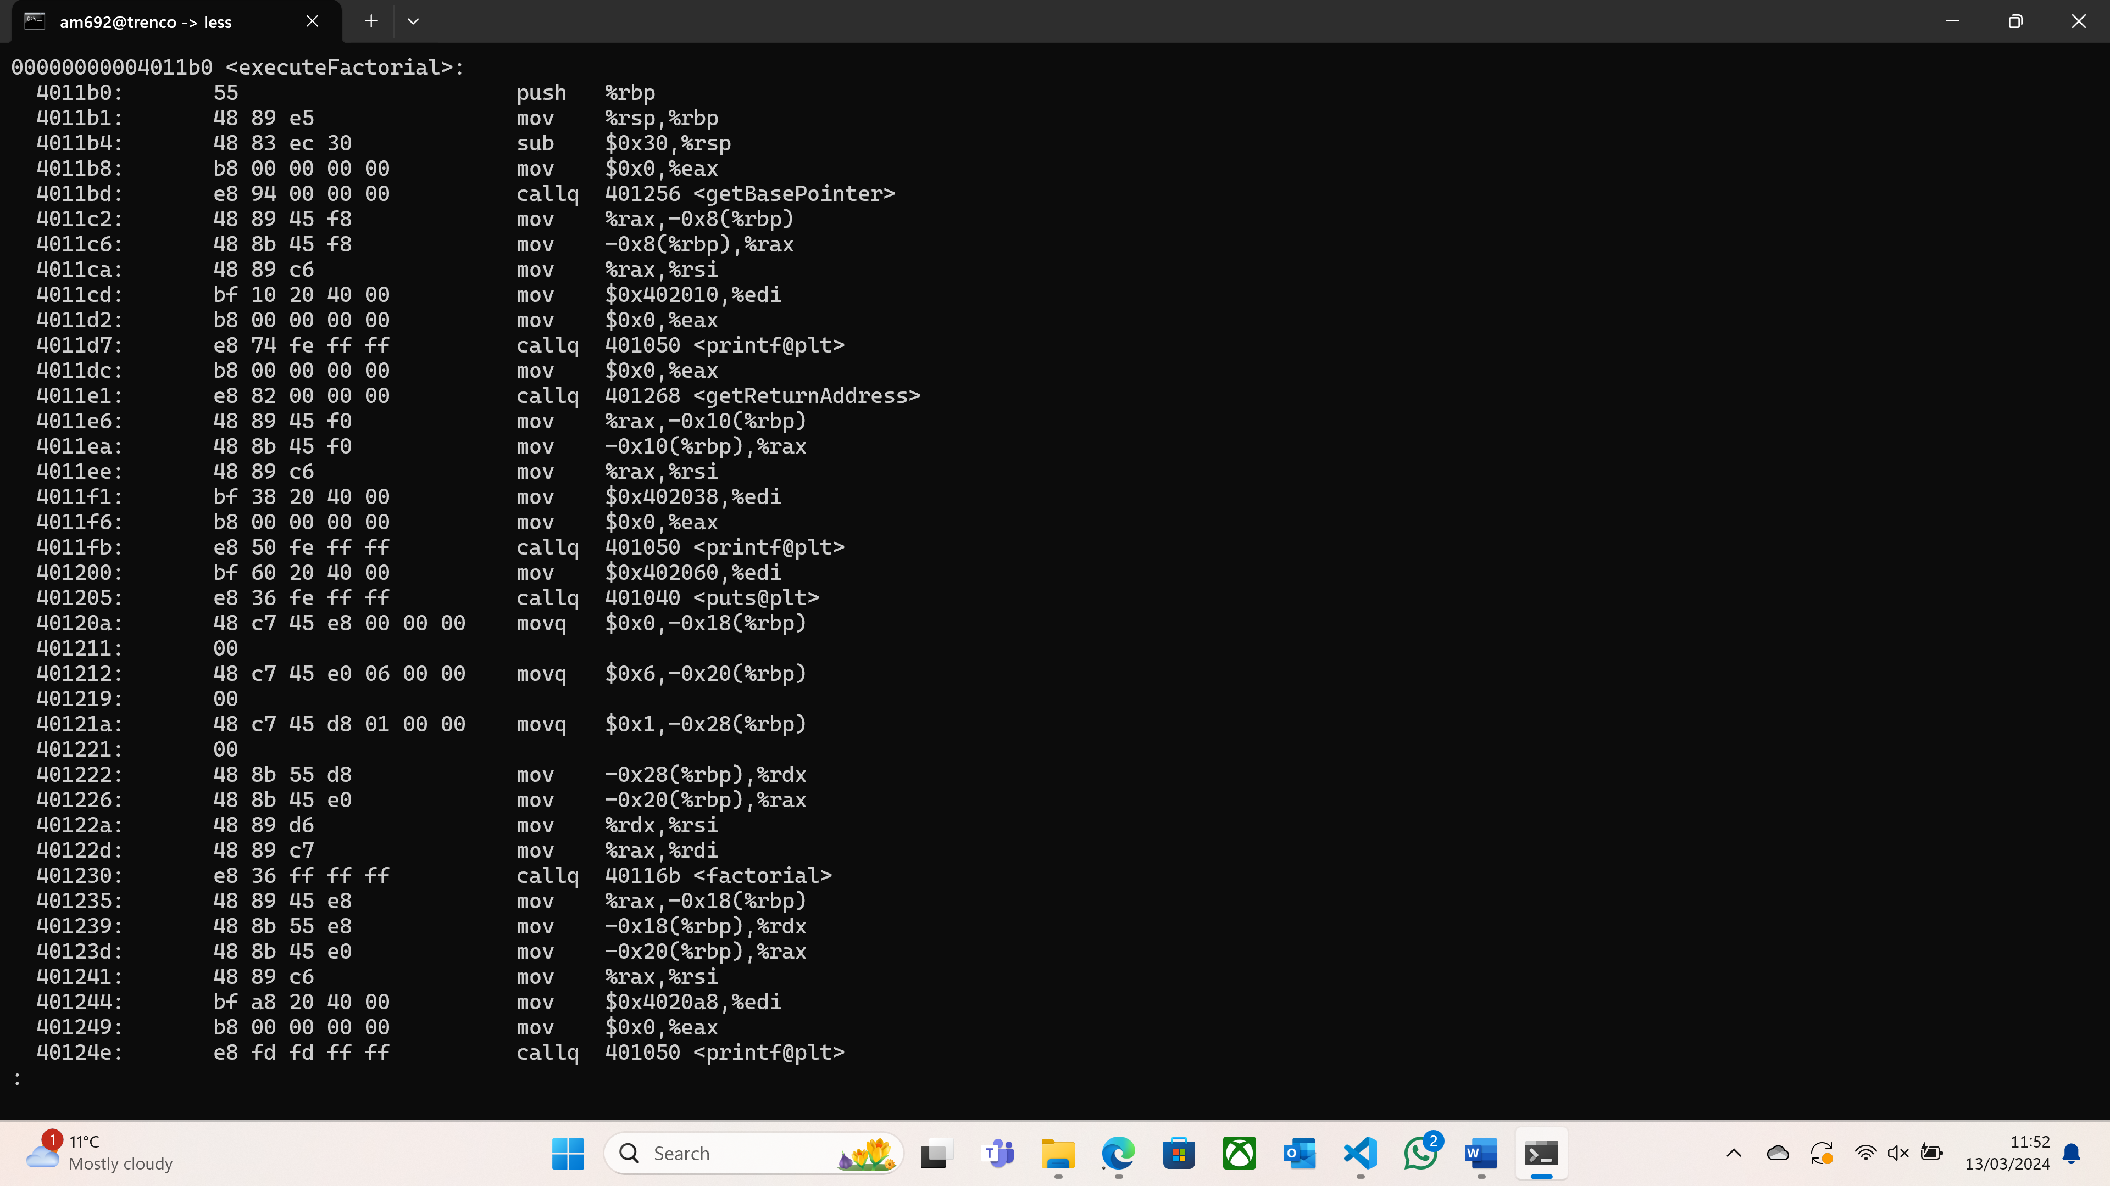

*Figure 9: Disassembly output for executeFactorial*

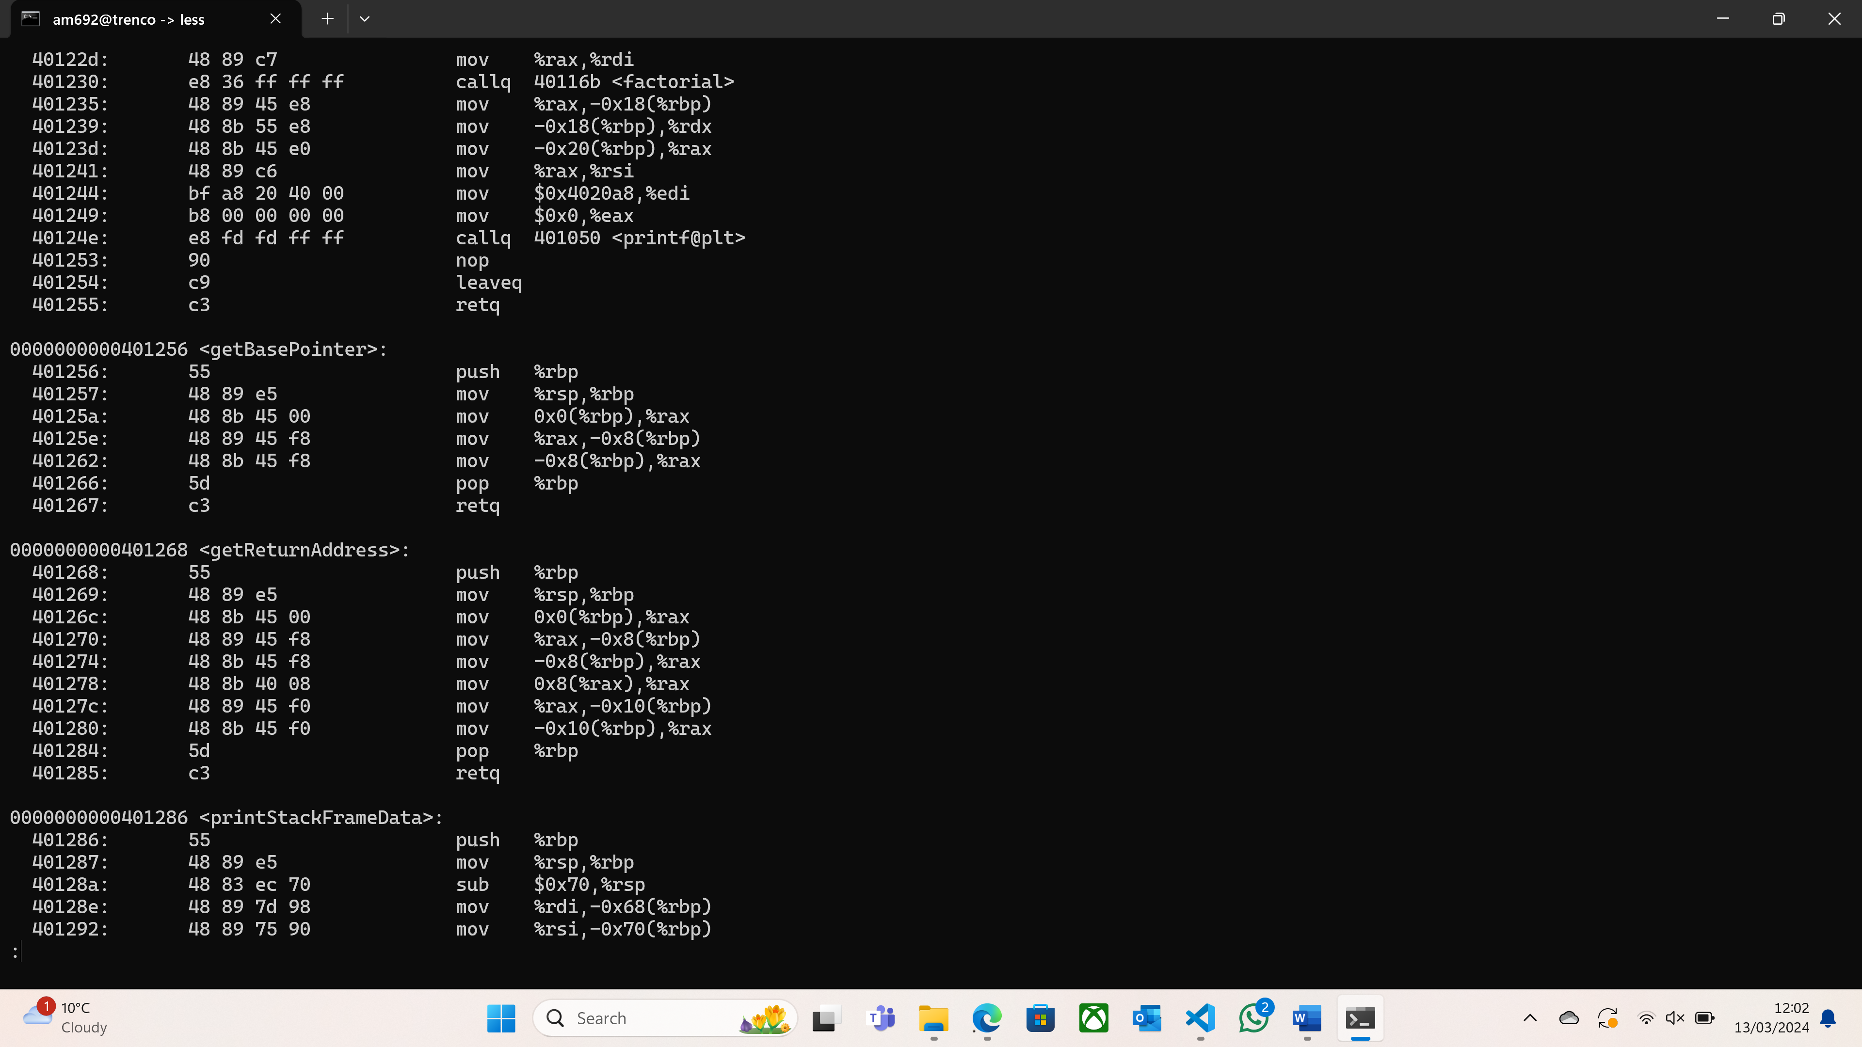

*Figure 10: Disassembly output for getBasePointer and getReturnAddress*

For each function, the 6-digit hexadecimal number in the first line corresponds to the function’s address. Therefore, the machine needs to use this address to call the function. We notice that every time the *callq* operation is used in *executeFactorial* (see *Figure 9*), the address that follows is the same as the first address in the other functions (see *Figures 7, 8* and *Figure 10*). Note that I didn’t include screenshots for *printStackFrameData*, *printStackFrames*, and the *main* function in TryStackFrames.c, but the previously explained statement also holds for these three functions.

**Conclusion**

All in all, I have found this practical extremely challenging at first, as I had no idea what all those hexadecimal numbers represented. I also had a difficult time understanding what was expected of me in this practical. However, when I finally grasped the meaning of those numbers, and how all parts of the code fitted together, everything became clearer, and the practical became way easier.